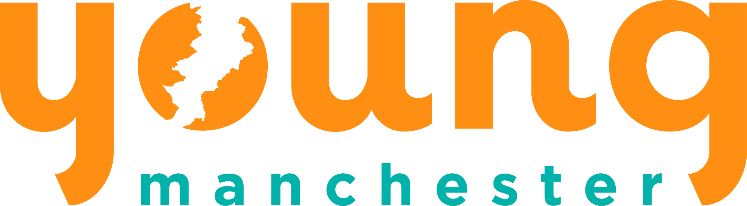

Equality and Diversity Monitoring Form

Young Manchester is an equal opportunities employer and positively encourages applications from suitably qualified and eligible candidates regardless of sex, race, disability, age, sexual orientation, gender reassignment, religion or belief, marital status, or pregnancy and maternity.

The information collected below will allow us to monitor our workforce and applications and ensure we continue to be an inclusive employer.

Any information you provide is confidential, will be separated from your application and does not form part of the application process.

Gender

Man 🗆
Woman 🗆
Intersex 🗆
Non-binary 🗆
Prefer not to say 🗆

If you prefer to use your own term, please specify here …………………….

Are you married or in a civil partnership?
Yes 🗆
No 🗆
Prefer not to say 🗆

Age 18-25 🗆 26-29 🗆 30-34 🗆 35-39 🗆 40-44 🗆 45-49 🗆 50-54 🗆 55-59 🗆 60-64 🗆 65+ 🗆 Prefer not to say 🗆

What is your ethnicity?
Ethnic origin is not about nationality, place of birth or citizenship. It is about the group to which you perceive you belong. Please tick the appropriate box

White
English 🗆 Welsh 🗆 Scottish 🗆 Northern Irish 🗆 Irish 🗆
British 🗆 Gypsy or Irish Traveller 🗆 Prefer not to say 🗆
Any other white background, please write in:

……………………………………………….….

Mixed/multiple ethnic groups
White and Black Caribbean 🗆 White and Black African 🗆 White and Asian 🗆 Prefer not to say 🗆 Any other mixed background, please write in:

……………………………………………….….

Asian/Asian British
Indian 🗆 Pakistani 🗆 Bangladeshi 🗆 Chinese 🗆 Prefer not to say 🗆
Any other Asian background, please write in:
……………………………………………….….

Black/ African/ Caribbean/ Black British
African 🗆 Caribbean 🗆 Prefer not to say 🗆
Any other Black/African/Caribbean background, please write in:

……………………………………………….….

Other ethnic group
Arab 🗆
Prefer not to say 🗆
Any other ethnic group, please write in:

Do you consider yourself to have a disability or health condition?
Yes 🗆
No 🗆
Prefer not to say 🗆

What is the effect or impact of your disability or health condition on your ability to give your best at work? Please write in here:

……………………………………………….….

The information in this form is for monitoring purposes only. If you believe you need a ‘reasonable adjustment’, then please discuss this with your manager, or the manager running the recruitment process if you are a job applicant.

What is your sexual orientation?
Heterosexual 🗆
Gay woman/lesbian 🗆
Gay man 🗆
Bisexual 🗆
Prefer not to say 🗆

If you prefer to use your own term, please specify here

……………………………………………….….

What is your religion or belief?
No religion or belief 🗆
Buddhist 🗆
Christian 🗆
Hindu 🗆
Jewish 🗆
Muslim 🗆
Sikh 🗆
Prefer not to say 🗆
If other religion or belief, please write in:

……………………………………………….….

Do you have caring responsibilities? If yes, please tick all that apply

None `` 🗆
Primary carer of a child/children (under 18) 🗆
Primary carer of disabled child/children 🗆
Primary carer of disabled adult (18 and over) 🗆
Primary carer of older person 🗆
Secondary carer (another person carries out the main caring role) 🗆
Prefer not to say 🗆

